**Exercise 1.**

1. **A graph of a triangle with a red line and blue line

   Description automatically generated**
2. **A graph of a graph of a line

   Description automatically generated with medium confidence**
   1. The projection u1 is longer than v compared to the first one.
3. **A graph of a function

   Description automatically generated**
   1. The projection u1 is going the opposite direction of v.
4. Projv(au) would equal a⋅projv​(u). projau​(u) = projv​(u) since the length of v does not affect the projection of u.

**Exercise 2.**

1. 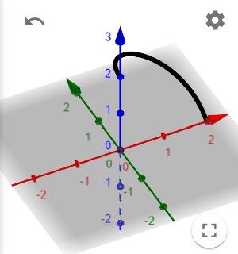

**Exercise 3.**

1. A screenshot of a graphing game

   Description automatically generated

**Exercise 4.**

1. Domain: (x2+y2≠0)

**Exercise 5.**

1. A screenshot of a graph

   Description automatically generated
   1. It looks similar to a plane away from 0, because the term (1/(x2+y2) approaches 0 as it moves further away from (0,0), which makes the whole function look like the plane f(x,y) = y.

**Exercise 6.**

1. 